**Lab 1**

**Part 1: To Create and Activate a New AWS Account**

**Key points**:

I. To use your @my.bcit.ca email address (**recommend**).

II. Have your credit card ready before starting this lab.

III. After finishing Lab 1, you only need to submit your sign-off sheet in Learning Hub.

1. Open the AWS home page by clicking [Amazon Web Services (AWS) home page](https://aws.amazon.com/)

2. **Choose** Create an AWS Account.

3. You need to create a Root user account. In Root user email address, enter your email address, edit the AWS account name, and then **Click** Verify email address.

Note: make sure to use your own email address.

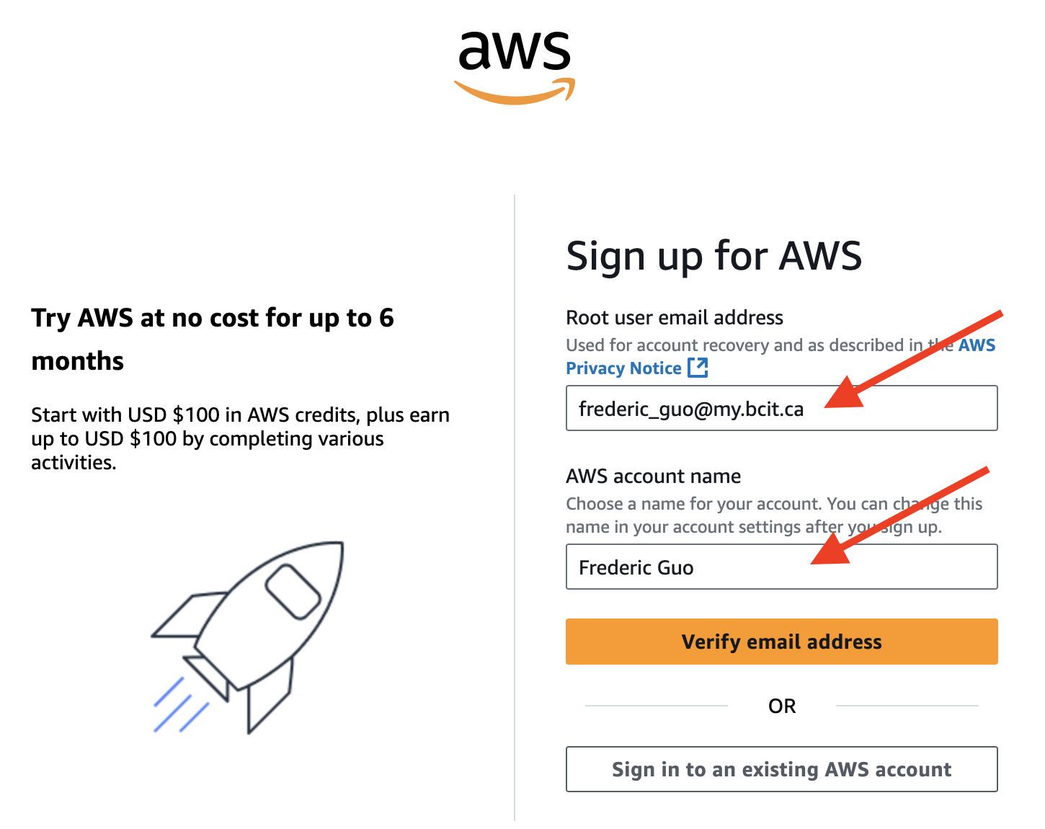

Should see this form:

4. An AWS verification email will be sent to your mailbox with a verification code. Check your mailbox and use the given code to verify your email address. **Note:** make sure touse your own verification code.

5. Enter your Root user password and confirm root user password, and then choose Continue.

6. Enter your own information. Read it through before accepting the AWS Customer Agreement and then choose Continue for following steps.

7. Choose free plan

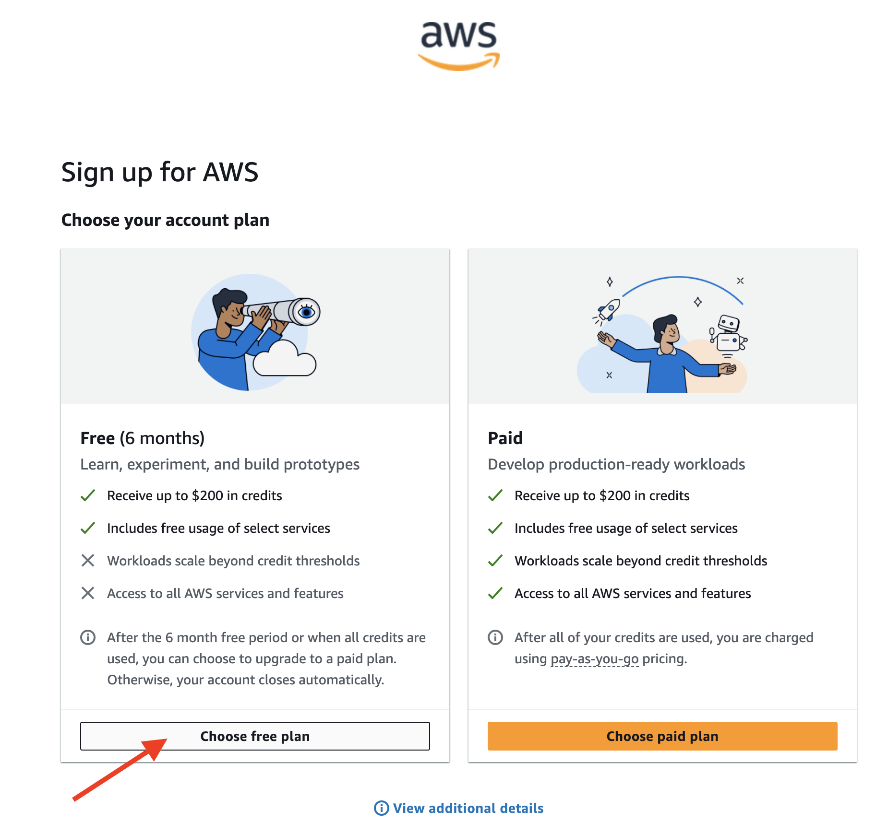

8. On the Billing information page, enter the information about your payment method and then choose “Verify and continue” (Note: if you don’t have a credit card, get one and work on it later.)

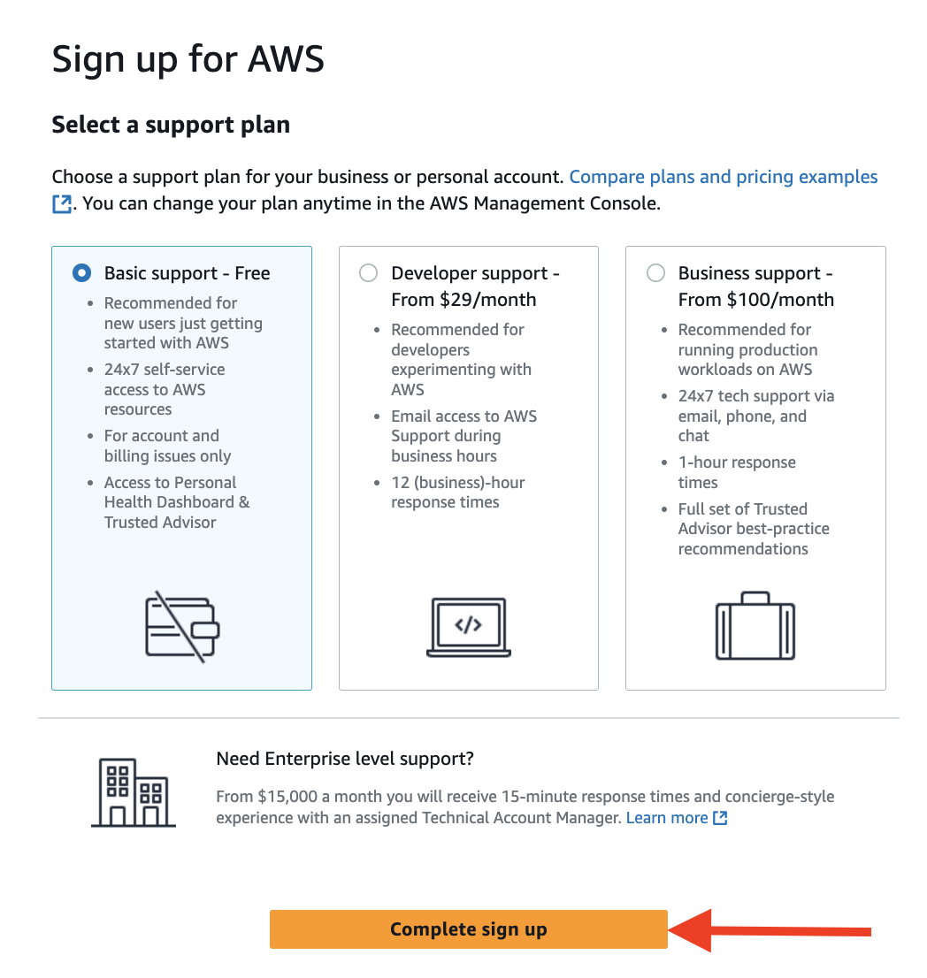

Then, you should see this page:

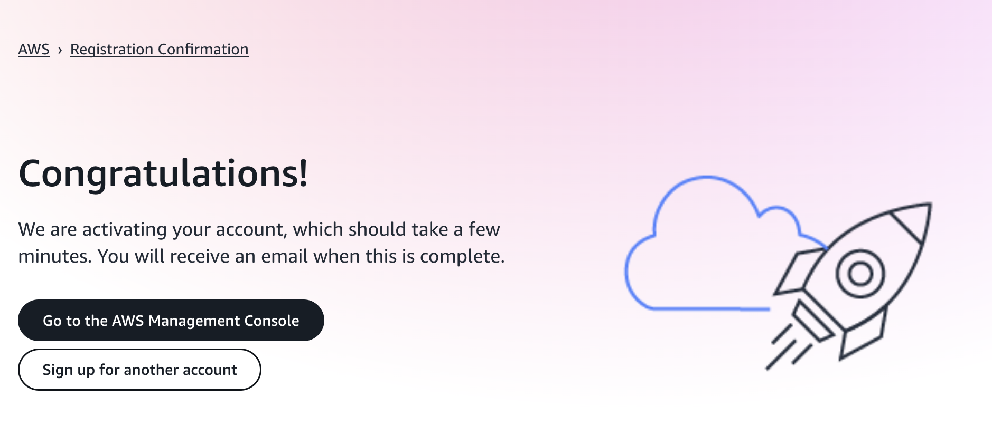

10. Click **Go to the AWS Management Console**

**Part 2: To Add MFA to your AWS User Login**

Now, you have access to your account and can possibly change configurations or delete resources in the account. Therefore, you need an extra layer of protection on top of your username and password (as root user). You need to enable MFA (password you know + security device you own) to protect your account. The major benefit of MFA is that if your password is stolen or hacked, your account is not compromised.

1. Log in your AWS account (You may skip this step, if you just finished Part 1)

1. Go to the IAM Dashboard

Then you see this page:

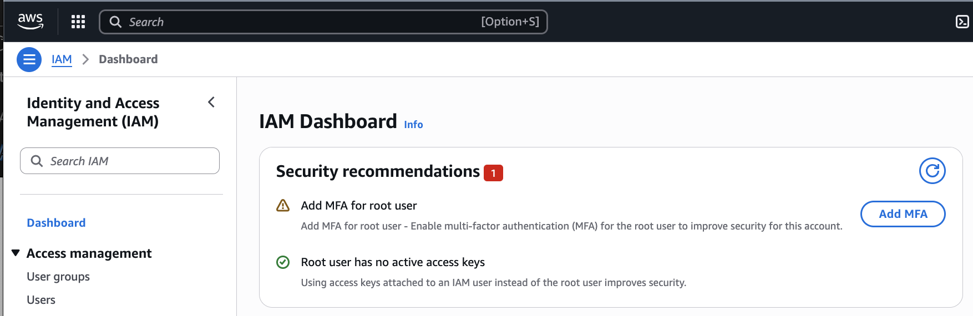

1. Activate MFA (Multi-Factor Authentication) for your root user.

Note: make sure to do this for your IAM user later.

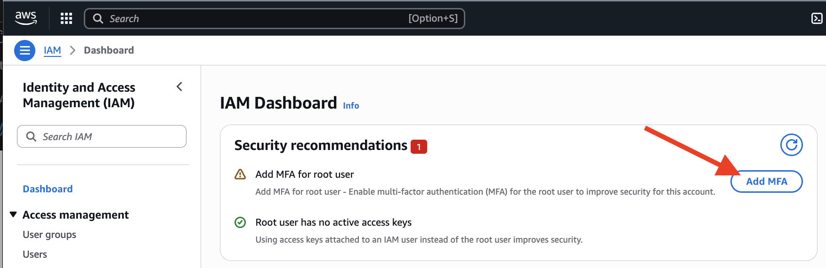

You should see a page like below, choose **Authenticator app** option, then “Next”.

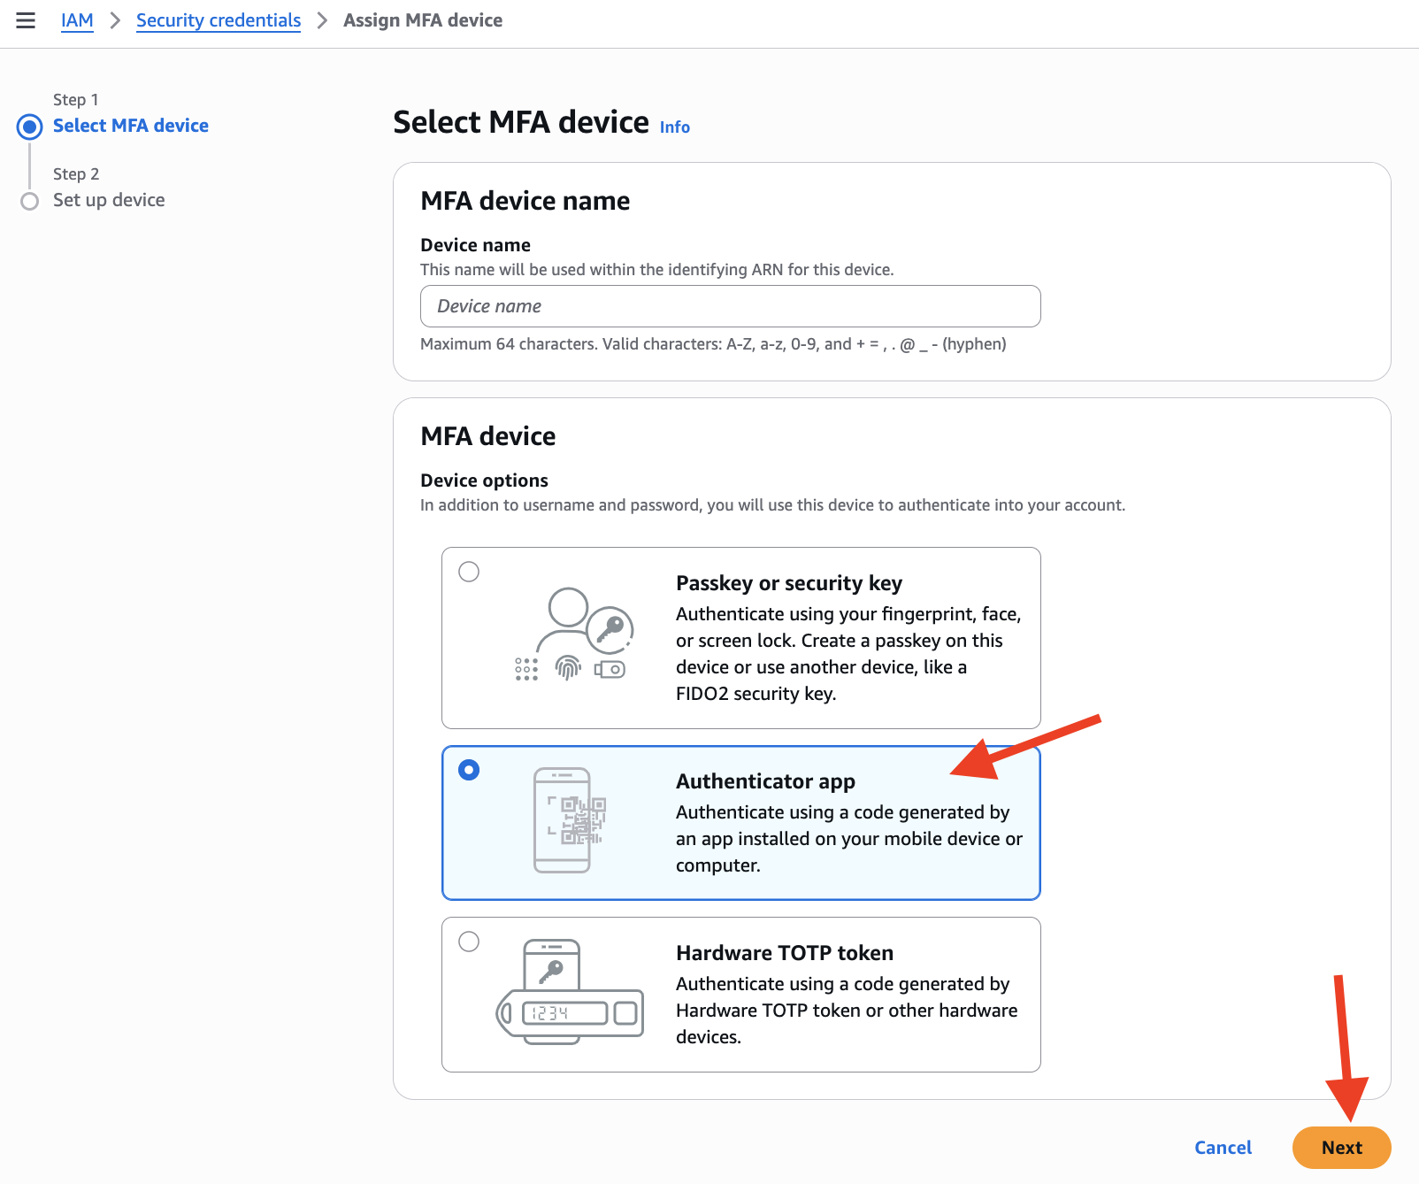

4. Download, install, and configure a virtual MFA application on your mobile device such as Google Authenticator, Microsoft Authenticator, Authy etc. **Note**: AWS also supports hardware MFA such as YubiKey, Feitian, Gemalto (3rd party), and SurePassID (3rd party), etc.

**Ref**. <https://aws.amazon.com/iam/features/mfa/>

5. After installing, run your authenticator on your device and then scan the barcode on the page of step 2.

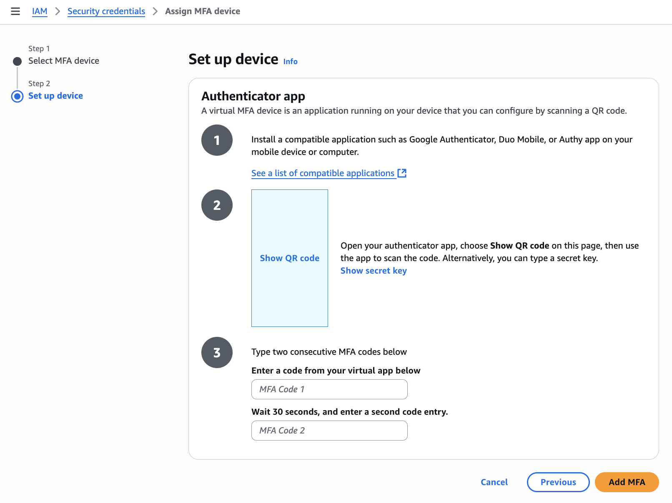

Note: after scanning, you need to put in two consecutive codes. It means after putting in one code as “MFA code 1”, you wait till this code got expired on your mobile then you see another code, you put the new code in as “MFA code 2”

After clicking **Add MFA** button**,** you might see a message like this:



**Task 1**: Show your instructor your Multi-factor authentication section to get sign-off

Now, your IAM dashboard should show “Root user has MFA”

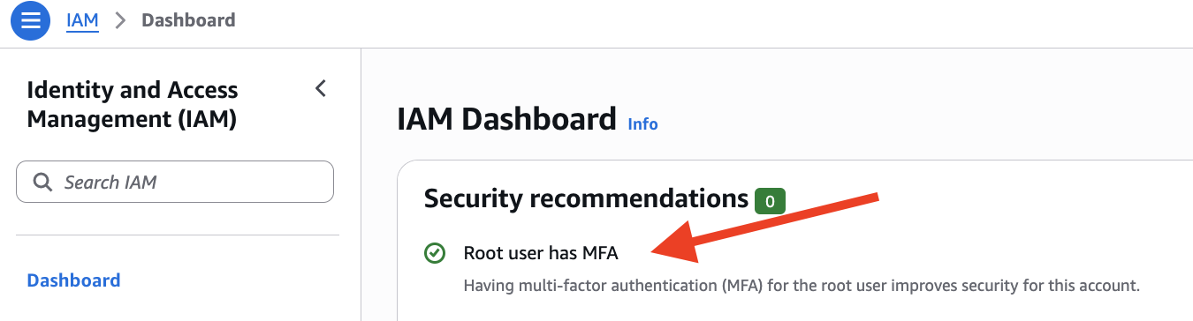

**Note**: when you want to remove or enroll new authenticator, you may get back here.

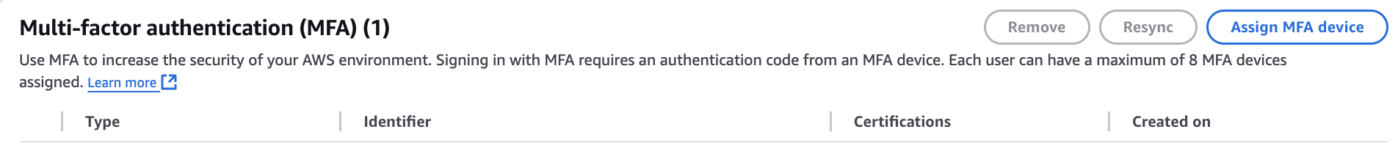

**Part 3: Create an individual IAM user**

AWS Identity and Access Management (IAM) is an important tool which can be used to securely control access to AWS resources. You use IAM to control who is authenticated (signed in) and authorized (has permissions) to use resources. You first AWS user has been created above by using your email address is Root user of your account. It is the best practice that not to use the Root User for your everyday tasks, even the administrative ones. The best practice is to ONLY use the root user to create your first IAM user. Instead, you can assign your IAM user with appropriate roles. The following steps are going to demonstrate how to create an IAM user with administrator role.

1. Login as AWS Root User (you’ve already done so in Part 2)
2. Open IAM ( typing in IAM in the top search bar, then you should see it)

Then, click **Users**

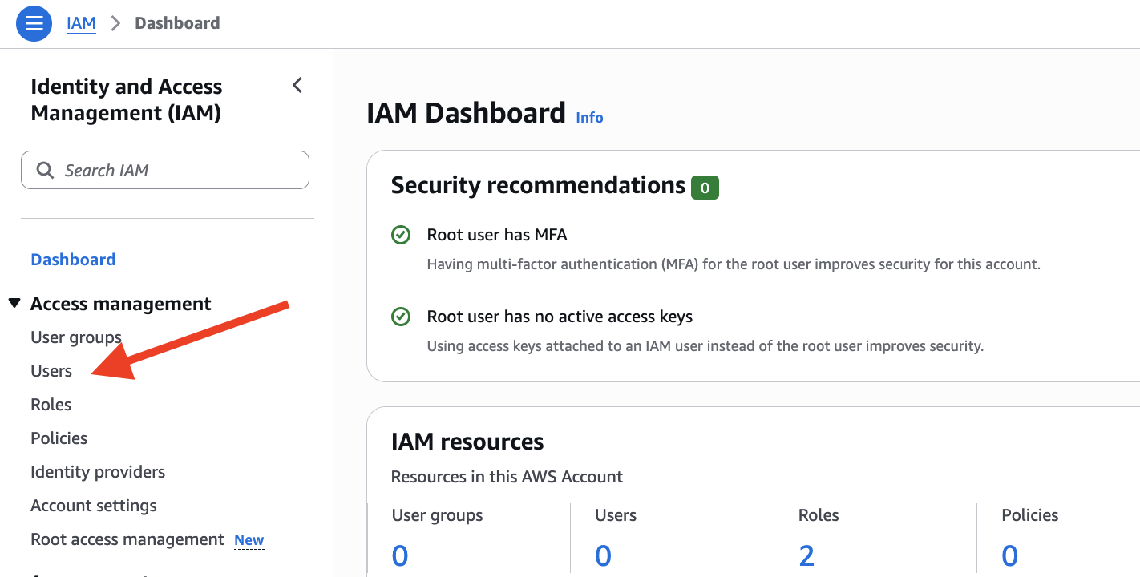

1. Click **Create user** button.

1. Type in your IAM username (your choice) and password and then click **Next** to proceed to Step 2: Set permissions.

1. Create an admin user group

You might see this message at the top of the page:

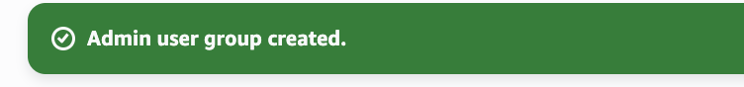

1. Check the checkbox to add user to user group, then click **Next** to proceed to Step 3 Review and create

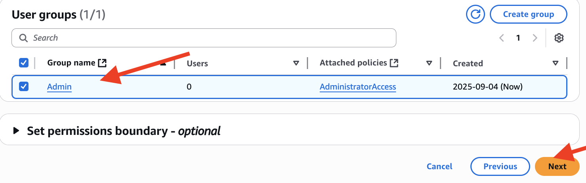

1. Add tags. You can use the key to filter resources

1. Review your new IAM ruse and then click **Create user**  button.

You might see a message like this:

1. Download your new_user_ credentials.csv file. It includes you sign-in URL.

Note: make sure to do this download step, you may not be able to do this after this page.

Note: if you lost (or forgot to download) your .csv file, you may find your sign-in URL here:



9. Logout your Root user and then login your new IAM user account

**Note**: The account id will be filled in automatically if you use login URL. You also can login here, aws.amazon.com by using Account ID or Account alias.

As we choose in an earlier step, you will be asked to change your password after you first time log in.

**Task** 2: Enroll MFA for your new IAM user

Provide a screenshot of your MFA enrollment for your new account. See the example as follow:

When you are done, show this to your instructor to get sign-off and then log out.

Hint:

**Part 4: AWS Budget Setup**

1. Go to AWS console at: <https://aws.amazon.com> and login as Root user.

2. At the top-right corner, click on the dropdown menu next to your username.

3. Select “Billing and Cost Management.”

1. In the side menu (on the left), under “Budgets and Planning” section, click “Budgets”

Side Notes: You may explore/monitor your costs in different views.

**Note**: You can query or filter your cost by services such as Rote 53, EC2 etc. In addition, if you manage different projects and you are asked to provide a solution to determine the specific expenses associated with each project. You can use AWS Billing and Cost Management to activate cost allocation tags and create reports that are based on the project tags. See the group by **Tag** above.

1. Click Create a budget button.

1. Open info menu by clicking the info button (circle i) in the side bar on the right.

1. Choose Tutorials tab

1. Choose Create a monthly budget (advanced) by clicking Start tutorial button.

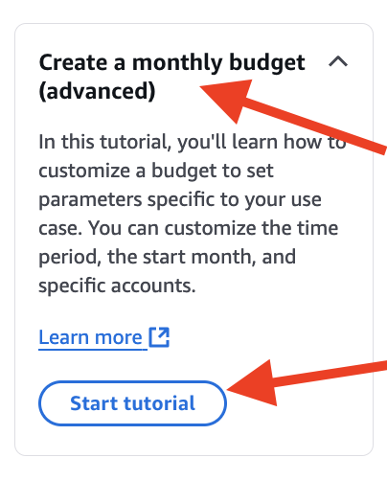

1. Follow the steps in tutorial to make your budget.

Budget name: My AWS Budget

Budget amount($): 0.02

Threshold: 100%

Email recipients: (Your daily email)

Note: You skip **Step 4: Attach actions – optional**

1. After reviewing, click Create budget button to proceed.

You may see this message for success.

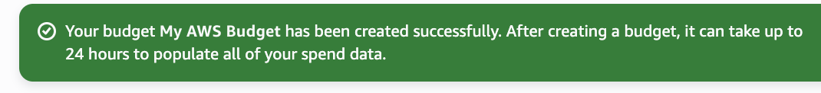

And/or this:

1. Go back to Budgets page, and then show your budget overview to your instructor to get sign-off.

More details:

Note #1: do not delete your budget !!!

Note #2: do not make many budges, not all free.